|  |  |
| --- | --- |
|  | Version  1 |

Waste Storage and Staging site Selection Tool

U.S. Environmental Protection Agency

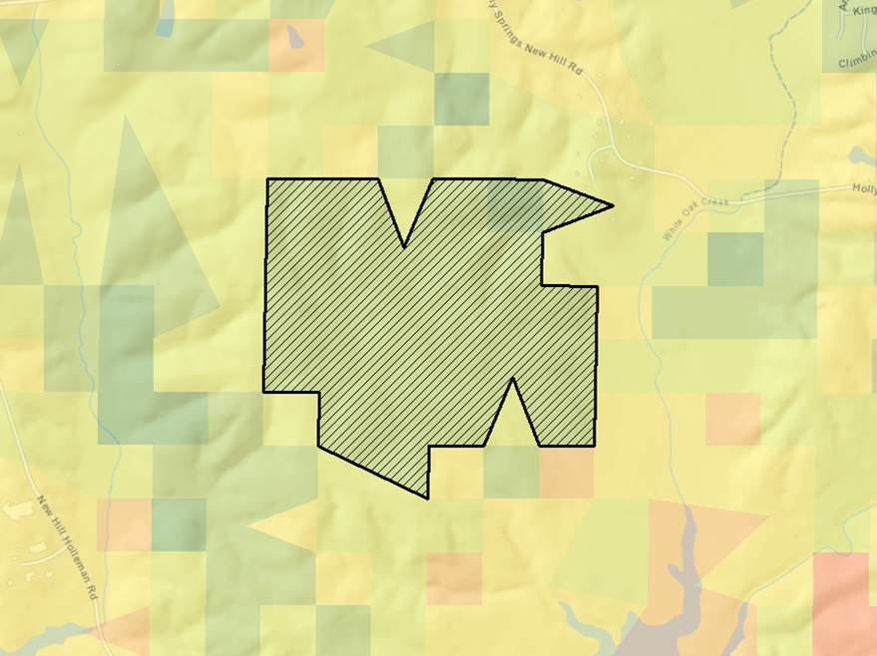User’s Guide

u.s. Environmental protection agency

WASTE STORAGE AND STAGING SITE SELECTION TOOL

U.S. Environmental Protection Agency

Homeland Security Research Program

Research Triangle Park, NC 27711

**Disclaimer**

This tool was created by the U.S. Environmental Protection Agency through its Office of Research and Development’s Homeland Security Research Program (HSRP). The contents of this guide do not necessarily reflect the views of the Agency. Mention of trade names, products, or services does not convey official EPA approval, endorsement, or recommendation.

**Acknowledgements:**

Timothy Boe

Acronym/Abbreviation List

|  |  |
| --- | --- |
| AOI | Area of Interest |
| BLM | Bureau of Land Management |
| CBRN | Chemical, Biological, Radiological or Nuclear |
| DCMD | Decontamination and Consequences Management Division |
| DEM | Digital Elevation Model |
| DHS | United States Department of Homeland Security |
| DOD | United States Department of Defense |
| DOE | United States Department of Energy |
| DOT | United States Department of Transportation |
| EJSCREEN | Environmental Justice Screen |
| EPA | United States Environmental Protection Agency |
| FEMA | Federal Emergency Management Agency |
| GIS | Geographic Information System |
| GPS | Global Positioning System |
| HHW | Household Hazardous Waste |
| HIFLD | Homeland Infrastructure Foundation-Level Data |
| HSG | Hydrologic Soil Group |
| HSRP | Homeland Security Research Program |
| LULC | Land Use Land Cover |
| NEI | National Emissions Inventory |
| NHD | National Hydrography Dataset |
| NHSRC | National Homeland Security Research Center |
| NOAA | National Oceanic and Atmospheric Administration |
| NPS | National Park Service |
| NTD | National Transportation Dataset |
| SQL | Structured Query Language |
| SSURGO | Soil Survey Geographic Database |
| USACE | United States Army Corps of Engineers |
| USDA | United States Department of Agriculture |
| USFWS | United States Fish and Wildlife Service |
| USGS | United States Geological Service |

**Table of Contents**

1. Introduction 1

How to Use This Guide 1

Point of Contact 2

Description 2

Systems Approach 3

1. Design and Methodology 1

Temporary Storage and Staging Site Avoidance Criteria 5

Temporary Storage and Staging Site Favorable Characteristics 5

Temporary Storage and Staging Site Additional Considerations 6

Examples of Temporary Storage and Staging Site Locations 6

1. Installation & Setup 7

Minimum System and Software Requirements 7

Install Pillow (Optional) 8

Install the Tool 8

Configure Default Geodatabase Location 9

Project Setup 10

1. Obtain Essential Data Layers 11
2. Run Tool Utilities 13

Establish Area of Interest 14

Step 1. AOI Setup 15

Step 2. Load New AOI 17

Step 3. Delete AOI (optional) 19

Step 4. Rename AOI (optional) 19

Create Scenario 20

Step 1. Scenario Setup 21

Step 2. Load New Scenario 21

Step 3. Delete Scenario (optional) 22

Step 4. Rename Scenario (optional) 22

Step 5. Duplicate Scenario (optional) 23

Step 6. Add Scenario to Map (optional) 23

1. Run the Suitability Analysis 24

Step 1. Confirm Suitability Criteria 24

Step 2. Specify Criteria Weight 27

Format Suitability Symbology 28

Add Secondary Data to Support Analysis (optional) 30

Select Your Designated Staging Areas 32

Modify Storage/Staging Area Attributes (optional) 33

Step 3. Finalize Staging Parcel Selection 34

Step 4. Export/Save Results 36

Results Output 38

Create and Compare More than One Scenario 38

1. Troubleshooting 39

**List of Figures**

Figure 1. General Tool Workflow 2

Figure 2. Systems Thinking Approach for CBRN Incidents 3

Figure 3. Waste Storage and Staging Tool Model Framework 3

Figure 4. ArcGIS Geoprocessing Workflow 4

Figure 5. Extracted Tool Assets 8

Figure 6. Storage Staging Site Tool 9

Figure 7. Storage Staging Site Util 9

Figure 8. Default Geodatabase Option 10

Figure 9. Enable Tasks Pane 13

Figure 10. Enable Catalog Pane 14

Figure 11. Establish Area of Interest Task 14

Figure 12. Area of Interest Tools 15

Figure 13. A1 AOI Setup 15

Figure 14. A2 Load New AOI 17

Figure 15. Draw AOI Tool 17

Figure 16. Example AOI Polygon 18

Figure 17. A3 Delete AOI 19

Figure 18. A4 Rename AOI 19

Figure 19. Create Scenario Task 20

Figure 20. Create Scenario Tools 20

Figure 21. B1 Scenario Setup 21

Figure 22. B2 Load New Scenario 21

Figure 23. B3 Delete Scenario 22

Figure 24. B4 Rename Scenario 22

Figure 25. B5 Duplicate Scenario 23

Figure 26. C1 Add Scenario to Map 23

Figure 27. Run Suitability Analysis Task 24

Figure 28. Suitability Analysis Tools 24

Figure 29. Step 1 Confirm Suitability Exclusion Criteria 27

Figure 30. Step 2 Specify Weights for Essential Layers 28

Figure 31. Select Suitability Symbology 29

Figure 32. Set Selection Environment 32

Figure 33. Interactive Selection Method 33

Figure 34. Selected Features 33

Figure 35. Edit Attributes 34

Figure 36. Step 3 Finalize Staging Selection 34

Figure 37. Final Staging Selection Output 35

Figure 38. Step 4 Export Report Screen – Disabled Map Graphic 36

Figure 39. Step 4 Export Report Screen – Map Graphic Enabled 37

**List of Tables**

Table 1. Essential Data Layers and Potential Sources 2

Table 2. Minimum ArcGIS Pro System and Software Requirements 7

Table 3. Default Suitability Criteria for Essential Layers 26

Table 4. Candidate Datasets and Map Layers for Base Layers and Storage/Staging Criteria 30

# Introduction



1

CHAPTER

Learn about this Geographical Information System (GIS) tool that applies spatial information and analysis technologies to locate and prioritize potential waste storage and staging locations to support response and recovery efforts

Large-scale disasters have the potential to generate a significant amount of waste. For example, Hurricane Katrina and the Joplin Missouri tornado resulted in 100 million and 1.5 million cubic yards of waste, respectively. Man-made chemical, biological, radiological, or nuclear (CBRN) incidents either by way of terrorism, war, or accident have the potential to generate as much or more waste, and both natural and man-made incidents are prone to generate some form of hazardous waste.

Recovery is profoundly impacted by waste management issues and the strategies selected to manage them. The quantification, segregation, transportation, and storage of waste can be an arduous and costly undertaking. Furthermore, these processes are intricately linked with the decisions made throughout the recovery timeline. Therefore, the remediation, including waste management, must be holistically considered. Understanding these complex interactions can be facilitated by using models and tools that adhere to the “system-of-systems” approach. To better understand and predict waste management issues, the Environmental Protection Agency’s (EPA’s) Homeland Security Research Program (HSRP) is developing a suite of tools and resources for planning and recovery purposes. EPA’s Waste Storage and Staging Site Selection Tool uses spatial information and analysis techniques to support conducting a suitability analysis to identify candidate areas for consideration. The tool was developed to help decision makers better understand potential options for managing waste and to illuminate potential capacity constraints to inform increased preparedness.

## How to Use This Guide

The purpose of this guide is to provide the necessary information to operate the tool. Described in this guide are methods for installing, configuring, and operating the tool. It is **recommended** that users have previous experience with and a working knowledge of ArcGIS*®* before operating the tool. This guide explains required data sources, explains how to customize the relative significance of specific criteria in the analysis, and suggests how to evaluate the output of the tool. The guide also provides information describing how the tool preprocesses and combines the data sources in the tool, as well as instructions for pre-processing essential data if users choose to use sources other than the data that are provided with the tool.

**icon keY**

 Valuable Tip

 Important Note

 Estimated Processing Time

The “icon key” to the right contains symbols used throughout this guide to highlight important information and additional guidance.

## Point of Contact

Timothy Boe

US EPA Office of Research and Development

Center for Environmental Solutions and Emergency Response

Homeland Security Research Program

919-541-2617 office

919-541-0496 fax

[boe.timothy@epa.gov](mailto:boe.timothy@epa.gov)

## Description

The Waste Storage and Staging Tool identifies and ranks potential locations for staging and storing waste. Using a site suitability analysis, the tool considers complicating suitability factors such as soil type, land cover, topography, ease of transportation, and proximity to surface waters. The tool will analyze the various siting criteria for a specified geographic area to identify candidate sites and their total available land surface areas. These criteria can be ranked according to degree of importance and automatically evaluated according to “best fit.” Users can combine the resulting suitability ratings with other important geospatial data to aid in the selection of candidate areas. The tool will allow a user to designate one or more areas within a geographic area of interest, specify attributes and rationale for selection, and save the output for use with other tools or analyses. Figure 1 below illustrates the general workflow of the tool.

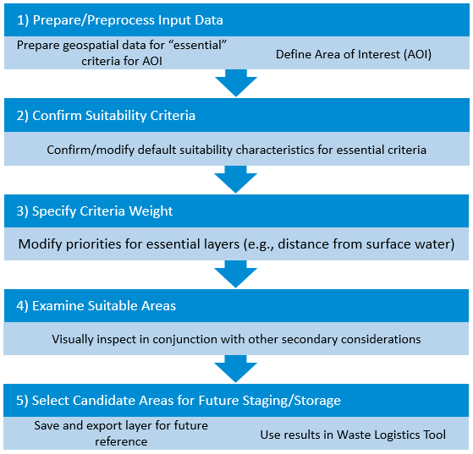

Figure 1. General Tool Workflow

## Systems Approach

For wide area incidents, response and recovery efforts may begin without collecting or considering essential information. Decisions related to the decontamination, waste management, and disposal strategy will affect the cost, duration, and effectiveness of the response. The process of understanding how these response activities influence one another and contribute to the overall solution is referred to as a systems approach. The systems approach recognizes that each response activity is coupled with another, where decisions made for one response action impact decisions and options that exist for another. For example, this dynamic is observed where the amount of waste to be managed is profoundly impacted by the decontamination approach that is selected, or when waste management constraints may drive decontamination decisions. As shown in Figure 2, as decisions are made, the resource demand may increase or decrease (typically the latter) in scale. With time, operationally driven decisions drive or tip the balance in favor of more resources. This approach typically causes remediation to become resource intensive in terms of cost and time (e.g., a specific decontamination method is costly, but is quicker). While EPA waste tools encourage a phased and cohesive approach (i.e., decontamination, waste estimation, and disposal), the tools compile and display results in a way that allows users to see the “big picture” and how minute changes in these approaches can greatly impact each individual response activity.

This “big picture” approach facilitates planning through scenario-based analyses that can increase preparedness, identify problematic scenarios, and ultimately identify effective solutions in advance of an incident. The systems approach seeks to balance the overall resource demand by leveraging the system as a whole and predicting an optimal outcome, which in return provides greater insight and improves decision making. The Waste Storage and Staging Site Selection Tool embodies this method by allowing the users to see how their decisions impact other operations (e.g., the need to decontaminate *in situ* due to limited capacity to stage/store waste) with regard to resource demand (e.g., cost and time).

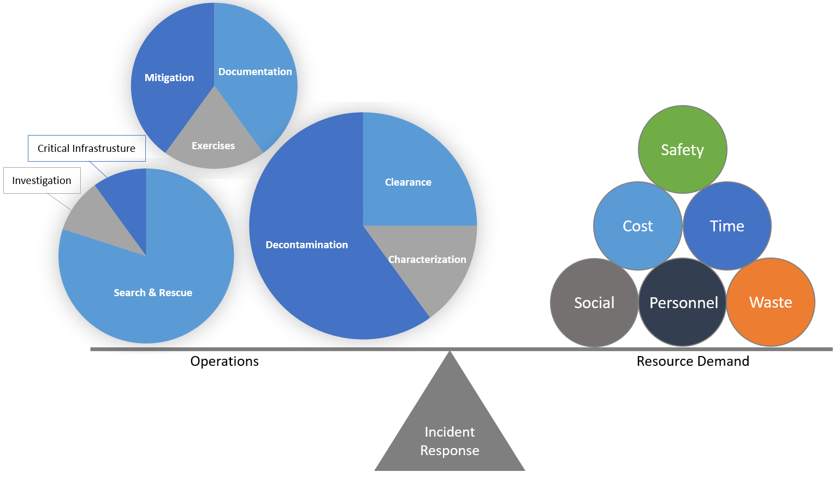

Figure 2. Systems Thinking Approach for CBRN Incidents

# Design and Methodology



2

CHAPTER

*Understand the tool’s underlying methodology, overall workflow, and important site selection considerations*

Research was conducted to identify efforts by states, regional planning authorities, and federal agencies (Department of Homeland Security (DHS), Federal Emergency Management Agency (FEMA), U.S. Army Corps of Engineers (USACE), etc.) to provide guidance for identifying and selecting sites for temporary waste storage and staging. DHS/FEMA has developed extensive guidance on planning and recovery from natural disasters and CBRN incidents that include generic guidance for identifying and selecting waste storage and/or disposal sites.[1],[2],[3],[4],[5] The United Nations Office for the Coordination of Humanitarian Affairs also has general and broad operational guidance on developing temporary waste disposal sites (Annex IV).[6] Additionally, numerous states and local governments have established disaster and debris management plans that also address waste storage, siting, and/or disposal issues.

The sources evaluated are generally consistent regarding key considerations for identifying candidate staging sites and tend to address geographically specific considerations. These geographically driven essential criteria drive the core suitability analysis parameters. The methodology for developing the suitability analysis is based on research by Cheng et. al.[7] Cheng reviewed literature related to siting selection criteria for temporary waste management treatment facilities that indicated identifying and determining weighting criteria as well as mapping and overlapping standardized layers are the four main steps in the process. Cheng used ArcGIS to conduct a land suitability analysis, and the ModelBuilder function of ArcGIS was applied to build an analysis model to identify candidate sites within a case study area. While the Cheng study did not consider storage and staging site selection criteria that might be unique to a wide-area contamination incident, the methodology developed and applied in the research study is directly applicable to the mechanics of the analysis.

ArcGIS Pro was used to develop a land suitability analysis model, incorporating data layers representing the essential selection criteria, including land use/land cover (LULC), slope, surface water, roads, and soil group. Essential data layers were downloaded from reliable sources such as those listed in Table 1; however, the tool contains the flexibility to use any higher quality data that users may find locally.

| Table 1. Essential Data Layers and Potential Sources | | | |
| --- | --- | --- | --- |
| **Base Layers** | **Suggested Dataset/Resource** | **Suggested Website/Source\*** | **Notes** |
| Land Use and Land Cover | National Land Cover Dataset | <https://www.mrlc.gov/data/nlcd-2011-land-cover-conus-0>  As of March 2020, the most recent data are LULC (2016) - <https://www.mrlc.gov/data/nlcd-2016-land-cover-conus>) | Click on “Download” and the download starts immediately |
| Slope** | Derived from Digital Elevation Models (DEMs) | <https://viewer.nationalmap.gov/basic/>  Elevation Products (3DEP), 1/3 arc-second DEM | Click “Find Products”, Download tile(s) for area of interest |
| Surface Water | U.S. Geological Survey (USGS), National Hydrography Dataset (NHD) | <https://www.epa.gov/waterdata/get-nhdplus-national-hydrography-dataset-plus-data#Download> Select the “NHDPlusV21_NationalData_Seamless_Geodatabas_Lower48_07.7z” download  NHD Area features – NHDWaterbody and NHDArea are feature layers of interest | Options include National Download or Data Region |
| Roads (ingress, egress, transportation arteries) | U.S. Department of Transportation (DOT) National Transportation Dataset (NTD) | <https://prd-tnm.s3.amazonaws.com/index.html?prefix=StagedProducts/Tran/Shape/>  State DOT offices are also a good source for road data. | Select TRAN_NATIONAL.zip File size warning: 6.7 GB  Smaller, state-specific data downloads are also available |
| Soil Group** | U.S. Department of Agriculture (USDA) Soil Survey Geographic Database (SSURGO) Downloader | <http://www.arcgis.com/home/item.html?id=cdc49bd63ea54dd2977f3f2853e07fff>  Be sure to download all map packages for the hydrologic units within your area of interest | Click “View Application”  Click the (i) in the top left of the screen for additional instructions Use the “Find Location” feature or change the basemap to more easily locate your area of interest |

* These are dependable national datasets; however, local data may have improved resolution for smaller study areas. Note that other data sources may require additional preprocessing for use in this model. Websites last accessed December 7, 2020.  
**These datasets are smaller, local datasets and therefore may require an iterative process to download the full coverage to match data to the area of interest.

Each criterion identified is a separate model input to ArcGIS. Figure 3 illustrates the overall framework for the model.

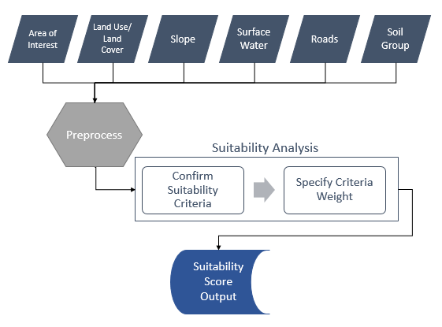

Figure 3. Waste Storage and Staging Tool Model Framework

ArcGIS Pro was used to create a Geoprocessing Environment to analyze each criteria layer. Geoprocessing models automate and document spatial analysis and data management processes that are created and modified with Python code. Conceptually, the model can be illustrated as a diagram that chains together sequences of processes and geoprocessing tools, using the output of one process as the input to another process. The ArcGIS Pro Geoprocessing Environment allows users to: (1) build a model by adding geoprocessing tools, map layers, datasets, and other data types, and connecting them to a process; (2) iteratively process every feature class, raster, file, or table in a workspace; and (3) run workflow steps. Several other geoprocessing tools are incorporated into the model at various steps, including: (1) Euclidian Distance; (2) Mask; and (3) Reclassify. Finally, the criteria map layers are overlaid to produce a final result for candidate sites. Figure 4 illustrates the ArcGIS Geoprocessing Environment workflow that forms the basis for the suitability model use to identify candidate storage and staging sites.

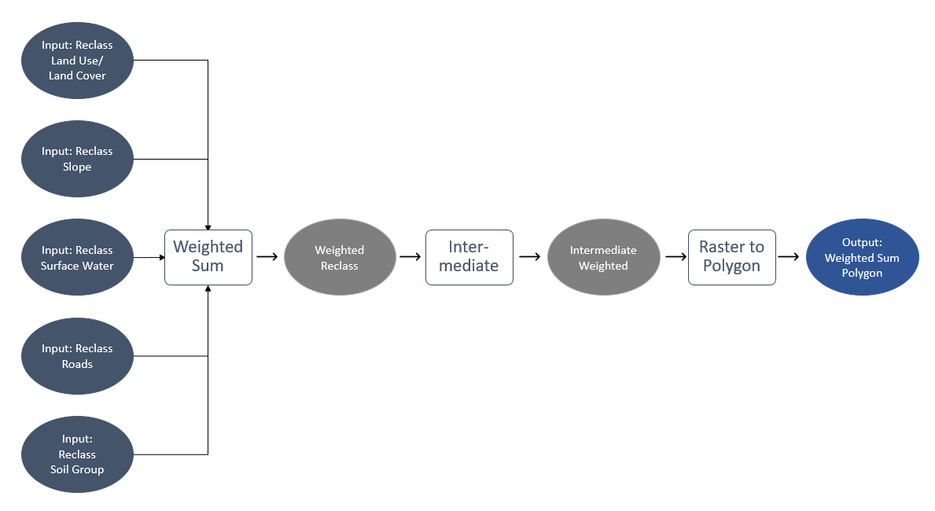

Figure 4. ArcGIS Geoprocessing Workflow

The tool analyzes the various siting criteria for a specified geographic area to identify candidate sites and their total available land surface areas. These criteria can be weighted according to degree of importance and automatically evaluated according to “best fit.” The tool is organized into a sequence of steps (described in subsequent sections of this user’s guide) that guides the user through identifying input data sources, preprocessing them, confirm suitability criteria, conducting the weighting analysis, and providing an output that identifies each portion of the area of interest by its relative suitability for waste storage and/or staging (see Figure 1).

Additional emphasis was placed on research previously conducted by EPA identifying criteria for the temporary storage and staging of contaminated wastes following radiological and biological contamination events. The first of those efforts resulted in a more extensive and detailed listing of criteria and considerations for identifying temporary storage and staging sites in the context of managing radioactively contaminated wastes.[8] EPA agrees that the criteria presented in those findings would largely be applicable for biocontaminated wastes as well.[9] HSRP’s research compiles and consolidates criteria into a more comprehensive framework that is broadly applicable and targeted to address issues specific to radiologically-related events when evaluating site selections. The important criteria resulting from HSRP’s research are discussed in more detail in the sections below and are recommended for priority consideration for use within the tool.

While the suitability model focuses on five essential criteria, additional criteria should be assessed in conjunction with the results of the tool. See Chapter 6 of this guide for details on locating and using other data to evaluate additional criteria discussed below.

## Temporary Storage and Staging Site Avoidance Criteria

In identifying potential waste storage and staging sites, locations characterized by any of the following designations should be **avoided:**

* Close proximity to wetlands (if near wetlands, establish buffer and/or turbidity barriers);
* Close proximity to public water supplies; well fields, surface waters (rivers, lakes, streams, drainage channels); potable water wells; sole source aquifers; priority groundwater management areas;
* Known presence of nearby threatened and endangered species;
* Critical animal and plant habitats;
* Rare ecosystems;
* Historic sites;
* Archaeological sites;
* Sensitive surrounding land uses – schools, nursing homes, hospitals, residential, etc.;
* Near obstructions such as power lines and pipelines;
* Abandoned quarries;
* Flood zones; and

Only accessible via single lane unpaved access roads.

## Temporary Storage and Staging Site Favorable Characteristics

Candidate waste storage and staging sites should have the following **favorable characteristics**:

* Good ingress/egress;
* Good transportation arteries nearby;
* Open flat topography;
* Sufficient buffer zone (approximately 60 percent of the area will be used for roads, buffers, burn pits, household hazardous waste (HHW) disposal areas, etc.);
* Reasonably large area to support large volumes of waste and materials; and

Favorable geological site conditions (stable ground, what are the groundwater levels, soil, or rock relatively impervious).

In addition to the above characteristics, public lands are preferred as to avoid costly leases. Private land should be considered only if public sites are unavailable.

## Temporary Storage and Staging Site Additional Considerations

In addition to the general geographic and topological characteristics listed above, the following should be taken into *consideration*:

* Prevailing winds that tend to carry air particulates and noise in a particular direction;
* Any disproportionately high or adverse impacts on minority or low-income populations;
* All transportation modes serving the site and disposal facility (rail, truck, vessel);
* Rail sidings in the Eastern US can be limiting for unit train lengths (number of railcars). Passenger trains have right of way and a unit train cannot be longer than the shortest siding en route to the waste disposal facility; and

Rail cars from East of the Mississippi River slated for Western US disposal will undergo at least one rail carrier exchange (e.g., CSX to Burlington Northern exchange in East St. Louis, IL).

## Examples of Temporary Storage and Staging Site Locations

Regardless of the specific criteria characterizing an area that may be used to prioritize locations, the *types of locations* could be considered as additional criteria to influence site selection:

* Commercial/industrial facilities (e.g., rail yards, industrial parks, licensed rad users, nuclear power plants);
* Federal facilities (e.g., U.S. Department of Energy (DOE) and U.S. Department of Defense (DOD) facilities);
* State/local facilities (e.g., solid waste management and hazardous waste facilities);
* Brownfield sites;
* Recycling facilities;
* Landfills;
* Transfer stations;
* Vacant lots that meet other criteria;
* Vacant buildings;
* Corporation yards;
* Parks;
* Parking lots;
* Rights-of-way;
* City/county-owned properties; and/or

Private properties.

Chapter 6 of this guide provides details on locating and using other data addressing the above criteria in conjunction with the suitability ratings that are generated by the tool.

# Installation & Setup



3

CHAPTER

Review step-by-step instructions to install and setup the Waste Storage and Staging Site Selection Tool

This chapter explains how to install and set up the tool. Before installation, confirm that your system meets or exceeds the recommended hardware and software requirements.

## Minimum System and Software Requirements

Table 2 describes the minimum system requirements and required software for the tool. Meeting the minimum system requirements does not guarantee that the tool will operate as intended; operation as intended is also tied to the performance of the ArcGIS Pro software package.

| Table 2. Minimum ArcGIS Pro System and Software Requirements | |
| --- | --- |
| **Required Software** | Esri’s ArcGIS Pro version 2.6 |
| **Required Extensions** | Spatial Analyst or Image Analyst extension[10] |
| **Optional Python Package** | Pillow [Python Imaging Library (PIL) Fork] |
| **Processor** | 2.2 GHz minimum processor |
| **RAM** | 4 GB minimum RAM, Recommended 8 GB RAM |
| **Screen Resolution** | 1024 x 768 pixels |
| **Operating System** | Windows 10 |
| **Disk Space** | 3.0 gigabytes (GB) available* |

* Additional disk space required to store data will vary based on data sources and the size of the areas of interest. See Chapter 4.

## Install Pillow (Optional)

To include a map image in the results export, Pillow, a Python Imaging Library fork, needs to be installed[11]. The tool also provides an option to export results without a map image to provide an option that does not require installation of the optional library.

 Note: Be sure to install Pillow in the ArcGIS Pro Python environments where the tool will be run if you are running multiple instances of Python and/or ArcGIS software.

## Install the Tool

Extract the contents of the compressed file, StagingSiteSelectionModel.zip, to your local drive. As shown in Figure 5, the extracted project is comprised of several folders.

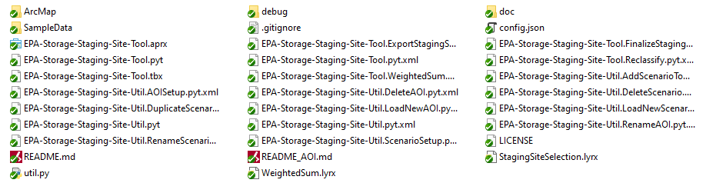

Figure 5. Extracted Tool Assets

Project assets include:

* **ArcMap** – Includes an older version of the Storage Site Staging Tool (July 2019).
* **Debug** – Includes scripts for debugging issues with initial setup and executing the tool.
* **Sample Data** – Includes geodatabases for sample Areas of Interest.
* NewMunster.zip is populated with a sample area of interest.
* **EPA Storage Staging Site Tool (gdb)** – This is the default geodatabase, which is created after the tool is run the first time. This location can be changed if storage space is limited; however, it is recommended to move the entire project to a location with the most available space.
* **Storage Staging Site Tool (tbx)** – A default empty toolbox that is included with the project (this can be ignored).
* **Storage Staging Site Tool (pyt)** – Includes four tools/processes (shown in Figure 6) that are used to conduct the site suitability analysis and create the final site selection feature class.

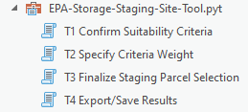

Figure 6. Storage Staging Site Tool

* **Storage Staging Site Util (pyt)** – Includes ten utility tools/processes that can be used to manager your environment (shown in Figure 7) that are used to create/modify the area of interest, create/modify the scenario, and add the scenario to the map.

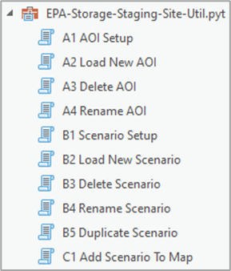

Figure . Storage Staging Site Util

## Configure Default Geodatabase Location

The default Geodatabase can become rather large depending on how large the AOIs are. The storage location of the default database can be changed (e.g., to an external hard drive), if the user requires more storage space. To do this follow the steps below:

1. Click the **Project** button  in the top left corner
2. Click **Options** in the left navigation bar, which will open the **Options** window
3. Click the **File** button Folder Icon | | Vector Images Icon Sign And Symbols next to the **Default geodatabase** input, as shown in Figure 8

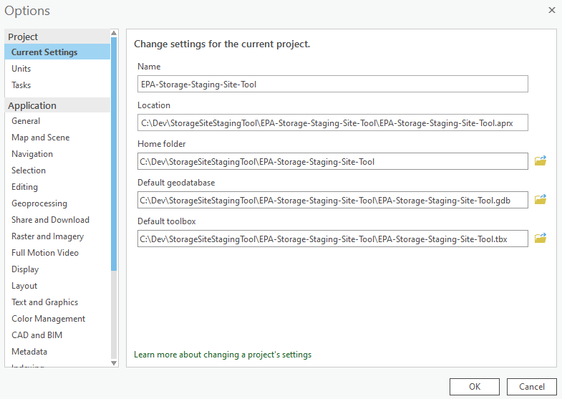

Figure . Default Geodatabase Option

1. Select the desired location for the **Default geodatabase**, provide a meaningful name, and click **OK**. If you already have a geodatabase that was created by the Staging tool, then you can select the existing geodatabase at this time and click **OK**.
2. Click **OK** on the **Options** window

## Project Setup

 The tool is primarily anticipated to support advanced planning efforts and serve as a catalyst to the start of important conversations. Users should expect to allocate up to a day, depending on their experience with ArcGIS and familiarity with the relevant datasets, to acquire, process, and execute the tool.

As described in Figure 1, several steps must be completed to gather input data required for the suitability model to run. The tool provides default essential data for use and requires retrieving and readying AOIs prior to running the model. Chapter 4 provides these instructions and illustrates the necessary steps to create a feature layer with candidate staging and/or storage locations from beginning to end. Chapter 6 describes details on locating and using additional secondary data to further evaluate candidate sites. Other considerations are expected to be relevant for site selection. Given that situational conditions are likely to drive priorities, the tool is flexible to allow users to add as many other secondary data layers as practicable to consider in conjunction with the suitability ratings that are generated by the model to aid in the selection of a site. Note: candidate sites can be identified using only the essential criteria discussed in Chapter 4.

# Obtain Essential Data Layers



4

CHAPTER

*Review the step-by-step instructions for gathering and preprocessing input data required to run the model*

The tool requires the usage of several essential data layers, listed below. EPA is providing a version of all the essential data layers[12], pre-processed and projected into the North America Equidistant Conic (WKID: 102010) spatial reference system, for use by the tool, including:

 These are very large datasets. You will likely need an external hard drive to download and extract data sets for use by the tool

* CONUS Slope raster
* CONUS NLCD 2016 raster
* CONUS NHD Polygon vectors
* CONUS TNM Transportation Road vectors
* CONUS EsriSSURGO Polygon vectors

State-specific Zip files are provided that include all five essential data layers. The essential data layers can be downloaded by copying and editing the following URL where you specify the state of interest by inserting the state code in the filename of the Zip file as shown in the example below:

* https://dmap-data-commons-ord.s3.amazonaws.com/HSRPSSS/HSRPSSS_ED_STATECODE.zip (e.g., https://dmap-data-commons-ord.s3.amazonaws.com/HSRPSSS/HSRPSSS_ED_AL.zip)

File names and corresponding file sizes are listed below.

* + HSRPSSS_ED_AL.zip (7.38 GB)
  + HSRPSSS_ED_AR.zip (7.2 GB)
  + HSRPSSS_ED_AZ.zip (13.43 GB)
  + HSRPSSS_ED_CA.zip (18.23 GB)
  + HSRPSSS_ED_CO.zip (12.81 GB)
  + HSRPSSS_ED_CT.zip (1017.54 MB)
  + HSRPSSS_ED_DC.zip (120.89 MB)
  + HSRPSSS_ED_DE.zip (535.81 MB)
  + HSRPSSS_ED_FL.zip (7.1 GB)
  + HSRPSSS_ED_GA.zip (8.38 GB)
  + HSRPSSS_ED_IA.zip (9.09 GB)
  + HSRPSSS_ED_ID.zip (10.62 GB)
  + HSRPSSS_ED_IL.zip (8.63 GB)
  + HSRPSSS_ED_IN.zip (6.08 GB)
  + HSRPSSS_ED_KS.zip (10.64 GB)
  + HSRPSSS_ED_KY.zip (6.39 GB)
  + HSRPSSS_ED_LA.zip (6.18 GB)
  + HSRPSSS_ED_MA.zip (1.5 GB)
  + HSRPSSS_ED_MD.zip (2.26 GB)
  + HSRPSSS_ED_ME.zip (4.23 GB)
  + HSRPSSS_ED_MI.zip (7.79 GB)
  + HSRPSSS_ED_MN.zip (11.41 GB)
  + HSRPSSS_ED_MO.zip (9.89 GB)
  + HSRPSSS_ED_MS.zip (7.02 GB)
  + HSRPSSS_ED_MT.zip (17.83 GB)
  + HSRPSSS_ED_NC.zip (7.3 GB)
  + HSRPSSS_ED_ND.zip (9.29 GB)
  + HSRPSSS_ED_NE.zip (10.4 GB)
  + HSRPSSS_ED_NH.zip (1.65 GB)
  + HSRPSSS_ED_NJ.zip (1.41 GB)
  + HSRPSSS_ED_NM.zip (14.5 GB)
  + HSRPSSS_ED_NV.zip (12.9 GB)
  + HSRPSSS_ED_NY.zip (6.95 GB)
  + HSRPSSS_ED_OH.zip (6.55 GB)
  + HSRPSSS_ED_OK.zip (9.73 GB)
  + HSRPSSS_ED_OR.zip (11.76 GB)
  + HSRPSSS_ED_PA.zip (6.79 GB)
  + HSRPSSS_ED_RI.zip (328.92 MB)
  + HSRPSSS_ED_SC.zip (4.41 GB)
  + HSRPSSS_ED_SD.zip (10.24 GB)
  + HSRPSSS_ED_TN.zip (6.68 GB)
  + HSRPSSS_ED_TX.zip (32.02 GB)
  + HSRPSSS_ED_UT.zip (10.07 GB)
  + HSRPSSS_ED_VA.zip (6.37 GB)
  + HSRPSSS_ED_VT.zip (1.66 GB)
  + HSRPSSS_ED_WA.zip (8.35 GB)
  + HSRPSSS_ED_WI.zip (7.89 GB)
  + HSRPSSS_ED_WV.zip (4.21 GB)
  + HSRPSSS_ED_WY.zip (12.12 GB)

# 

# Run Tool Utilities



5

CHAPTER

*Understand and follow the step-by-step instructions to run the model to create the area of interest and scenario.*

The following sections outline the sequence of steps that are required to create an area of interest and scenario on which to run a suitability analysis. Areas of interest are the spatially constrained units of analysis. AOIs can persist and be available for selection when defining a scenario. As AOIs are created, they are stored in a file geodatabase that may be stored within the project or in another location to facilitate sharing among users if stored in a commonly accessible location. Scenarios, in contrast, are representations of a specific analysis approach and are understood to be less permanent. Users may generate multiple scenarios using a single AOI where different suitability parameters are applied to evaluate different approaches. As described later, the tool allows users to duplicate scenarios to facilitate easily retaining a majority of scenario conditions and allowing users to make small modifications to assess the impact on results without having to start from scratch.

Users can either use the **Tasks** pane or **Catalog** pane to run the tools. The **Tasks** pane steps the user through the necessary steps to execute the tool. Users can skip unnecessary steps (e.g., when creating a new area of interest, the **Delete AOI** and **Rename AOI** steps can be skipped). To enable the **Tasks** pane, click the **View** tab in the ArcGIS Pro toolbar and then click the **Tasks** button as shown in Figure 9.

Figure 9. Enable Tasks Pane

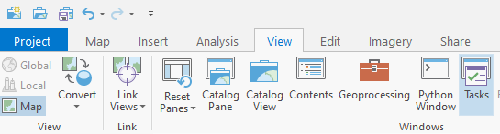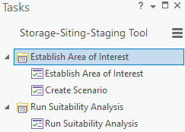

The **Catalog** pane exposes all steps and allows the user to freely jump between the various tools as needed. To enable the **Catalog** pane, click the **View** tab in the ArcGIS Pro toolbar and then click the **Catalog Pane** button as shown in Figure 10.

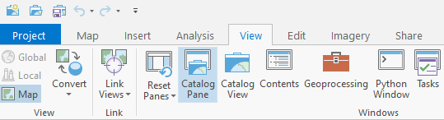 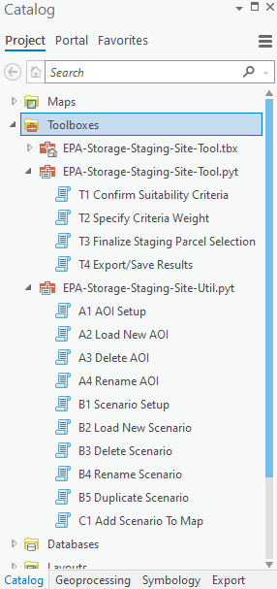

Figure 10. Enable Catalog Pane

## Establish Area of Interest

The following steps outline the steps that are required to create an area of interest. Some of these tasks can be skipped, depending on what is needed (e.g., when creating a new area of interest (AOI), the **Delete AOI** and **Rename AOI** steps can be skipped). Run the **Establish Area of Interest** task by double-clicking the **Establish Area of Interest** item in the Tasks pane, as shown in Figure 11.

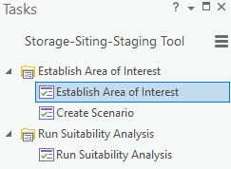 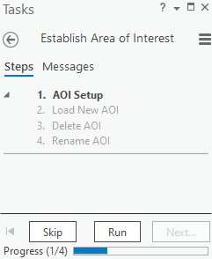

Figure 11. Establish Area of Interest Task

Alternatively, users can run the area of interest related tools directly from the Catalog pane, as shown in Figure 12.

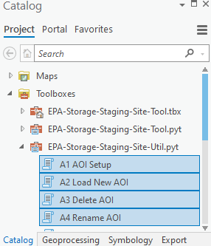

Figure 12. Area of Interest Tools

### Step 1. AOI Setup

The first step is to setup an AOI using the **AOI Setup** tool. Run the **AOI Setup** tool by clicking **Run** in the Tasks pane or by double-clicking on the **A1 AOI Setup** model in the **EPA-Storage-Staging-Site-Util.pyt** from the Catalog window. This will open the **A1 AOI Setup** model in the Geoprocessing pane, as shown in Figure 13. By default, the tool will store the AOI in the root directory of the project; however, you can select a specific location to store the area of interest by clicking the **File** button Folder Icon | | Vector Images Icon Sign And Symbols, next to **AOI Storage Location** input. The area of interest layer can be stored within in the project or outside of the project (e.g., on an external hard drive). If the user plans to use an existing AOI that was previously created via the Storage Staging Site tool, then the user can skip to

Figure 13. A1 AOI Setup

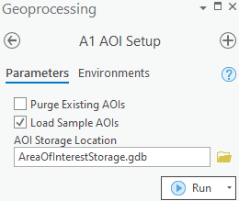

**Step 2. Load New** AOI. Users can optionally purge the project of existing AOIs by checking the **Purge Existing AOIs** item and or load sample AOIs by checking the **Load Sample AOIs**. Click the **Run** button to finalize the AOI Setup. If using the Tasks pane, click **Next Step** in the Tasks pane to continue to the next step.

### 

### Step 2. Load New AOI

The next step is to load the new AOI using the **Load New AOI** tool. Run the **Load New AOI** tool by clicking **Run** in the Tasks pane or by double-clicking on the **A2 Load New AOI** model in the **EPA-Storage-Staging-Site-Util.pyt** from the Catalog window. The model is flexible enough to accept any delineation of AOI (e.g., an administrative boundary such as a municipality or county, a plume outline, or manual selection). Note that while the tool currently supports any AOI within the continental United States, very large AOIs may not function well within the tool due to high data processing demands. The **A2 Load New AOI** tool will open in the Geoprocessing pane (see Figure 14) allowing you to create the area of interest. Clicking **Run** will execute the **Load New AOI** tool which will clip each essential input layer to the area of interest and format the AOI for storage. The final area of interest layer will also include the username of the user who created it, the creation date, and the date last updated.

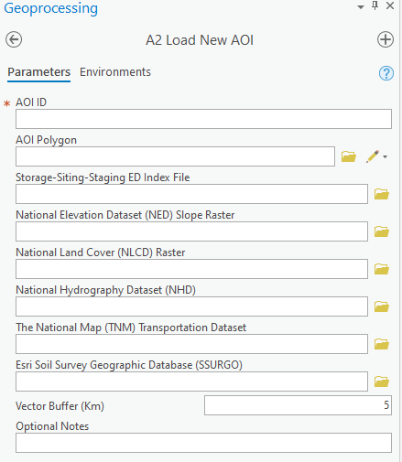

Figure . A2 Load New AOI

The following steps outline how to manually delineate an AOI polygon feature.

1. Enter a unique meaningful name in the **AOI ID** input (Name must not begin with an integer or include dashes).
2. Click Folder Icon | | Vector Images Icon Sign And Symbols to import an AOI from a file or click the  and click **Polygons** to manually draw an AOI on the map (see Figure 15).

 Note, there are other polygon shape drawing options available, but the **Polygon** option provides the greatest flexibility.

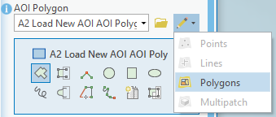

Figure 15. Draw AOI Tool

1. Manually delineate the AOI by clicking around the outer boundary of area of interest (see example shown in Figure 16). It may be helpful to use reference data such as roads, satellite imagery, or field-collected GPS coordinates to improve the accuracy of the AOI boundary.

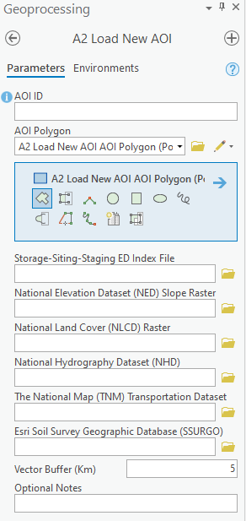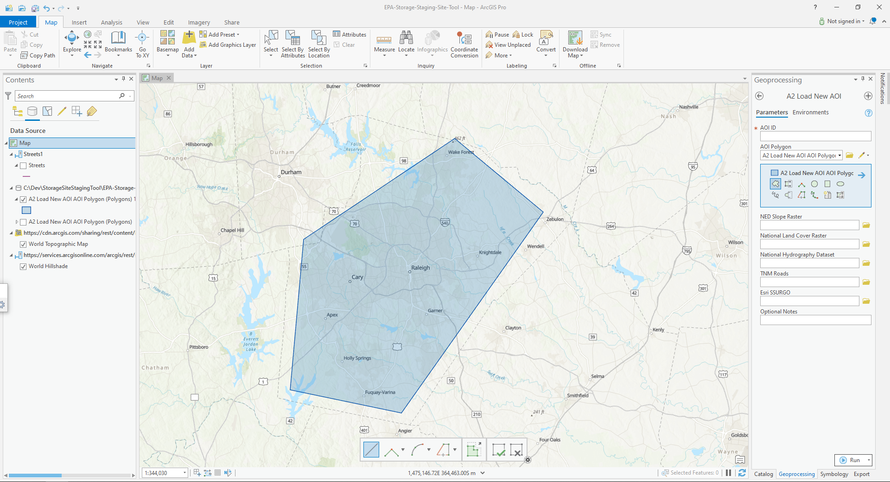

Figure 16. Example AOI Polygon

1. Next, if your are using EPA-supplied data, navigate to the “Storage-Siting-Staging-ED Index File” by clicking the **File** button Folder Icon | | Vector Images Icon Sign And Symbolsand the tool will automatically map datasets for you.

Otherwise, you can manually map essential data to corresponding datasets by following the remaining steps:

1. Select a **National Elevation Dataset (NED) Slope Raster** image by clicking the **File** button Folder Icon | | Vector Images Icon Sign And Symbols.
2. Select a **National Land Cover (NLCD) Raster** dataset by clicking the **File** button Folder Icon | | Vector Images Icon Sign And Symbols.
3. Select a **National Hydrography Dataset (NHD)** layer by clicking the **File** button Folder Icon | | Vector Images Icon Sign And Symbols.
4. Select a **The National Map (TNM) Transportation Dataset** layer by clicking the **File** button Folder Icon | | Vector Images Icon Sign And Symbols.

 Processing time may take several minutes depending on the processing power of your machine.

1. Select a **Esri Soil Survey Geographic Database (SSURGO)** layer by clicking the **File** button Folder Icon | | Vector Images Icon Sign And Symbols.
2. The **Optional Notes** input can be used to provide notes.
3. Click **Run** to finish loading the AOI.
4. Click **Next Step** in the Tasks pane to continue to the next step.

### Step 3. Delete AOI (optional)

The **Delete AOI** step can be used to delete an area of interest layer that is no longer needed. If you do not need to delete any AOIs click the **Skip** button in the Tasks pane. Run the **Delete AOI** tool by clicking **Run** in the Tasks pane or by double-clicking on the **A3 Delete AOI** model in the **EPA-Storage-Staging-Site-Util.pyt** from the Catalog window. This will open the **A3 Delete AOI** tool in the Geoprocessing pane, as shown in Figure 17. Select an AOI using the **AOI ID** drop down and click **Run**. Click **Next Step** in the Tasks pane to continue to the next step.

Figure 17. A3 Delete AOI

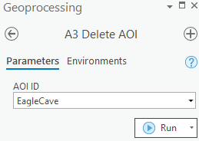

### Step 4. Rename AOI (optional)

Figure 18. A4 Rename AOI

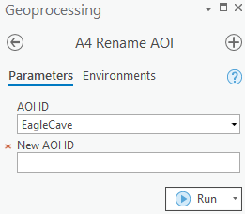

The **Rename AOI** step can be used to rename an area of interest layer. If you do not need to rename any AOIs click the **Skip** button in the Tasks pane. Run the **Rename AOI** tool by clicking **Run** in the Tasks pane or by double-clicking on the **A4 Rename AOI** model in the **EPA-Storage-Staging-Site-Util.pyt** from the Catalog window. Select an AOI using the **AOI ID** drop down, enter a new name for the AOI in the **New AOI ID** input, and click **Run**, as shown in Figure 18. Click **Finish** in the Tasks pane to complete the **Establish Area of Interest** task.

## Create Scenario

The following sections outline the sequence of steps that are required to create a scenario. Recall that scenarios are representations of a specific analysis approach. You can generate multiple scenarios using a single AOI where different suitability parameters are applied to evaluate different approaches. Some of the tasks in the **Create Scenario** task pan can be skipped. Depending on what is needed (e.g., when creating a new scenario, the **Delete Scenario** and **Rename Scenario** steps can be skipped). Run the **Create Scenario** task by double-clicking the **Create Scenario** item in the Tasks pane, as shown in Figure 19.

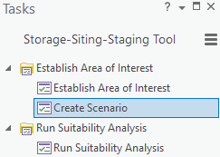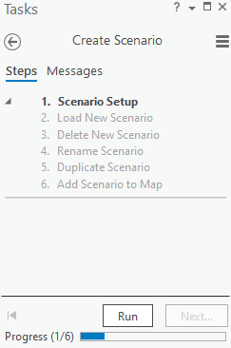

Figure 19. Create Scenario Task

Alternatively, users can run the scenario-related tools directly from the Catalog pane, as shown in Figure 20.

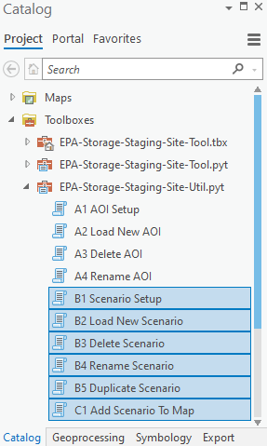

Figure 20. Create Scenario Tools

### Step 1. Scenario Setup

The next step is to create and validate the scenario tracking table using the **Scenario Setup** tool. Run the **Scenario Setup** tool by clicking **Run** in the Tasks pane or by double-clicking on the **B1 Scenario Setup** model in the **EPA-Storage-Staging-Site-Util.pyt** from the Catalog window. This will open the **B1 Scenario Setup** model in the Geoprocessing pane, as shown in Figure 21**.** Users can optionally purge all existing scenarios by checking **Purge Existing Scenarios**. By default, the scenario is stored in the project. If you would like to store the scenario elsewhere, follow the steps in **Configure Default Geodatabase Location**. Click **Run** to execute this step. Click **Next Step** in the Tasks pane to continue to the next step.

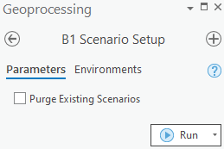

Figure 21. B1 Scenario Setup

### Step 2. Load New Scenario

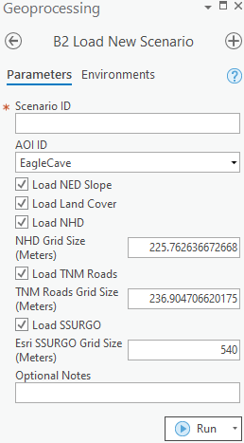

Figure 22. B2 Load New Scenario

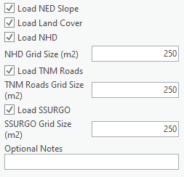

The next step is to load the scenario using the **Load New Scenario** tool. Run the **Load New Scenario** tool by clicking **Run** in the Tasks pane or by double-clicking on the **B2 Load New Scenario** model in the **EPA-Storage-Staging-Site-Util.pyt** from the Catalog window. This will open the **B2 Load New Scenario** model in the Geoprocessing pane, as shown in Figure 22. The final scenario layer will also include the username of the user who created it, the creation date, and the date last updated.

1. Enter a unique meaningful name in the **Scenario ID** input. Note: Do not start with an integer or include hyphens.
2. Select an AOI using the **AOI ID** drop down.
3. Uncheck **Load NED Slope** if the **NED Slope Raster** was not provided in **Step 2. Load New AOI**.
4. Uncheck **Load Land Cover** if the **National Land Cover Raster** was not provided in **Step 2. Load New AOI**.
5. Uncheck **Load NHD** if the **National Hydrography Dataset** was not provided in **Step 2. Load New AOI**.
6. Adjust the **NHD Grid Size**, if necessary.
7. Uncheck **Load TNM Roads** if the **TNM Roads** was not provided in **Step 2. Load New AOI**.
8. Adjust the **TNM Roads Grid Size**, if necessary.
9. Uncheck **Load SSURGO** if the **Esri SSURGO** was not provided in **Step 2. Load New AOI**.
10. Adjust the **Esri SSURGO Grid Size**, if necessary.
11. Click **Run** to load the scenario.
12. Click **Next Step** in the Tasks pane to continue to the next step.

### Step 3. Delete Scenario (optional)

The **Delete Scenario** tool can be used to delete a scenario that is no longer needed. If you do not need to delete any scenarios click the **Skip** button in the **Tasks** pane. Run the **Delete Scenario** tool by clicking **Run** on the Tasks pane or by double-clicking on the **B3 Delete Scenario** model in the **EPA-Storage-Staging-Site-Util.pyt** from the Catalog window. This will open the **B3 Delete Scenario** model in the Geoprocessing pane, as shown in Figure 23. Select a scenario using the **Scenario ID** drop down and click **Run**. Click **Next Step** in the Tasks pane to continue to the next step.

Figure 23. B3 Delete Scenario

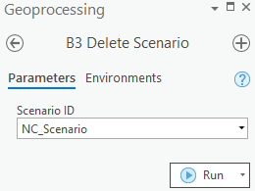

### Step 4. Rename Scenario (optional)

The **Rename Scenario** tool can be used to rename a scenario. If you do not need to rename any scenarios click the **Skip** button in the **Tasks** pane. Run the **Rename Scenario** tool by clicking **Run** on the Tasks pane or by double-clicking on the **B4 Rename Scenario** model in the **EPA-Storage-Staging-Site-Util.pyt** from the Catalog window. This will open the **B4 Rename Scenario** model in the Geoprocessing pane, as shown in Figure 24. Select a scenario using the **Scenario ID** drop down, enter a new name for the scenario in the **New Scenario ID** input, and click **Run**. Click **Next Step** in the Tasks pane to continue to the next step.

Figure 24. B4 Rename Scenario

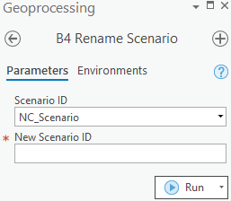

### Step 5. Duplicate Scenario (optional)

The **Duplicate Scenario** tool can be used to duplicate a scenario. For example, if you would like to alter only a few conditions but keep all other inputs the same, duplicating the scenario allows you to make a copy of the original without needing to carefully rebuild a whole new scenario for comparison. If you do not need to duplicate any scenarios click the **Skip** button in the **Tasks** pane. Run the **Duplicate Scenario** tool by clicking **Run** on the Tasks pane or by double-clicking on the **B5 Duplicate Scenario** model in the **EPA-Storage-Staging-Site-Util.pyt** from the Catalog window. This will open the **B5 Duplicate Scenario** model in the Geoprocessing pane, as shown in Figure 25. Select a scenario using the **Scenario ID** drop down, enter a name for the new scenario in the **New Scenario ID** input, and click **Run**. Click **Next** in the Tasks pane to continue to the next step.

Figure 25. B5 Duplicate Scenario

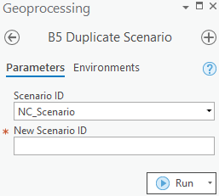

### Step 6. Add Scenario to Map (optional)

The **Add Scenario to Map** tool can be used to add a scenario to a different map. If a user has several scenarios, this utility allows you to expressly link specific scenarios to specific maps created within the project. Users can create a new map for every scenario and name the maps to match, or you can recycle the one map over and over, removing the old scenario and adding the new scenario in turn. Following the normal workflow using the various tool will plot the results on the map; however, this utility can be used to reorganize associations, as needed.

Figure 26. C1 Add Scenario to Map

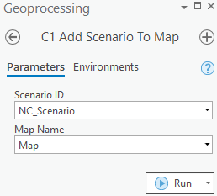

If you do not need to manage any scenarios/map associations, click the **Skip** button in the Taskspane; otherwise, run the **Add Scenario to Map** tool by clicking **Run** in the Tasks pane or by double-clicking on the **C1 Add Scenario to Map** model in the **EPA-Storage-Staging-Site-Util.pyt** from the Catalog window. This will open the **C1 Add Scenario to Map** model in the Geoprocessing pane, as shown in Figure 26. Select a scenario using the **Scenario ID** drop down, select a map in the **Map Name** drop down, and click **Run**. Click **Next Step** in the Tasks pane to continue to the next step.

# Run the Suitability Analysis



6

CHAPTER

*Understand and follow the step-by-step instructions to run the model to generate suitability ratings for the specified area of interest.*

The following sections outline the sequence of steps required to execute the suitability analysis. Run the **Run Suitability Analysis** task by double-clicking the **Run Suitability Analysis** item in the Tasks pane, as shown in Figure 27.

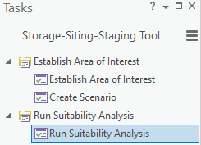 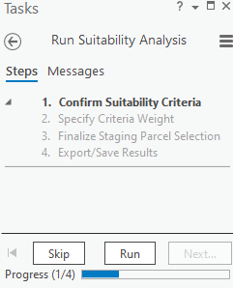

Figure 27. Run Suitability Analysis Task

Alternatively, run the suitability analysis tools directly from the Catalog pane, as shown in Figure 28.

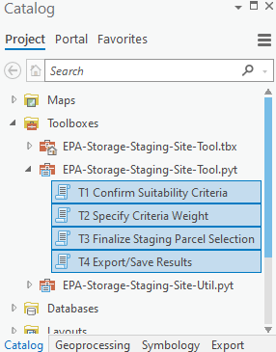

Figure 28. Suitability Analysis Tools

## Step 1. Confirm Suitability Criteria

The next step is to confirm suitability criteria for each of the extracted raster layers to categorize the data within each layer as suitable and not suitable areas. This step utilizes the **Con** tool to reclassify the data. You can manually edit the suitability criteria by adjusting the parameters directly within the tool to denote which are **not** suitable. The default output values are 1=suitable, 0=not suitable. Table 3 below describes the default suitability thresholds that are established for the analysis. For land use/land cover, land types to avoid include residential, forest, and agricultural areas. For the slope layer, suitable areas are the flattest or areas with the lowest percent change. For the surface water layer, the most suitable areas are those more than 500 meters from any water source. For the road layer, the most suitable areas are between 200 meters and 500 meters from the road. For soils, suitable areas are those associated with the following hydrologic soil groups (HSG)[13]:

* Group C - Group C consists of soils with a layer that impedes the downward movement of water or fine textured soils and a slow rate of infiltration.
* Group D - Group D consists of soils with a very slow infiltration rate and high runoff potential. This group is composed of clays that have a high shrink-swell potential, soils with a high water table, soils that have a clay pan or clay layer at or near the surface, and soils that are shallow over nearly impervious material.

Group C/D - Group C/D soils naturally have a very slow infiltration rate due to a high water table but will have a slow rate of infiltration if drained.

| Table 3. Default Suitability Criteria for Essential Layers | | |
| --- | --- | --- |
| Essential Layer | Suitable (1) | Not Suitable (0) |
| **Land Use/Land Cover\*** | * Developed, Open Space (21) * Developed, Low Intensity (22) * Barren Land (Rock/Sand/Clay) (31) * Dwarf Scrub* (51) * Shrub/Scrub (52) * Grassland/Herbaceous (71) * Sedge/Herbaceous* (72)    *Alaska only | * Open Water (11) * Perennial Ice/Snow (12) * Developed, Medium Intensity (23) * Developed, High Intensity (24) * Deciduous Forest (41) * Evergreen Forest (42) * Mixed Forest (43) * Lichens* (73) * Moss* (74) * Pasture/Hay (81) * Cultivated Crops (82) * Woody Wetlands (90) * Emergent Herbaceous Wetlands (95) |
| **Slope** | < 10% change in elevation | > 10% change in elevation |
| **Surface Water (Distance from Water)** | > 500 m | < 500 m |
| **Road (Distance from Road)** | 200 m – 500 m | < 200 m and > 500 m |
| **Soil Infiltration[14]** | Hydrologic soil groups C, D, or C/D | Hydrologic soil groups A, B, A/D, or B/D |

*LULC codes from the 2011 MRLC dataset are included for reference (Source: <https://www.mrlc.gov/data/legends/national-land-cover-database-2011-nlcd2011-legend>, Last accessed May 10, 2019). While these codes are not likely to change, users should verify and apply the most appropriate LULC codes associated with the specific source data selected.

Once you confirm the suitability criteria, run the **Confirm Suitability Criteria** task by clicking **Run** from the Tasks pane or by double-clicking on the **T1 Confirm Suitability Criteria** model in the **EPA-Storage-Staging-Site-Tool.pyt** from the Catalog window. In the **T1 Confirm Suitability Criteria** model window shown in Figure 29 below, the user can confirm the default suitability classifications listed in the table above or update the classifications. You can manually edit the suggested suitability criteria by adjusting the parameters directly within the tool to denote which are not suitable (e.g., designating an additional soil HSG or adding another land use as not suitable). Some basic knowledge of structured query language (SQL) and/or conditional statements may be helpful to refine suitability logic.

 Note, users must know what fields/values are available within essential data selected for use in the application and how to query against them to accurately establish exclusion criteria.

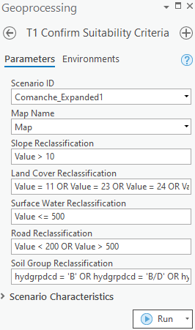

Figure 29. Step 1 Confirm Suitability Exclusion Criteria

Once the suitability classifications are confirmed, click **Run** to run the model. Running the model will create the reclassified raster layers in the **EPA-Storage-Staging-Site-Tool.gdb**. Click **Next Step** in the Tasks pane to continue to the next step.

 Processing time for county-level datasets is estimated to be less than one minute.

## Step 2. Specify Criteria Weight

The next step is to run all five reclassed raster layers using the **Specify Criteria Weight** tool. Run the **Specify Criteria Weight** tool by clicking **Run** in the Tasks pane or by double-clicking on the **T2 Specify Criteria Weight** model in the **EPA-Storage-Staging-Site-Tool.pyt** from the Catalog window. As shown in Figure 30 below, you can assign weights to each raster layer based on relative importance in the **T2 Specify Criteria Weight** Geoprocessing tool window. Note that weighting values can reflect any weighting scheme (i.e., while there are five variables, the weighting is not a linear ranking scale). This sub-step runs all five raster layers in the **T2 Weighted Sum** tool using the weights assigned to each criterion and converts the weighted sum raster into a polygon to facilitate calculating available area. Click **Run** to run the **T2 Weighted Sum** tool where a weighted sum layer will be created in the **EPA-Storage-Staging-Site-Tool.gdb**. The **T2 Weighted Sum** tool will automatically add the **WeightedSum** layer to the map. Click **Next** in the Tasks pane to continue to the next step.

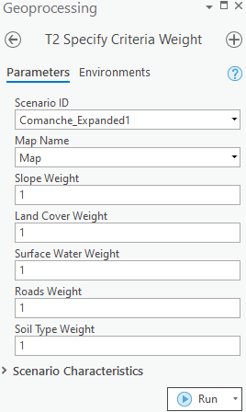

Figure 30. Step 2 Specify Weights for Essential Layers

## Format Suitability Symbology

To facilitate quick identification of potential staging sites, you can customize Symbology by clicking on the **WeightedSum** feature class in the **Contents** panel and click on the **Symbology** tab, as shown in Figure 31. Use the **Field 1** drop-down menu to select the **Suitability_Score** field. Use the **Color scheme** drop-down menu to select the dark green to red option. To reverse the Color scheme, click **More** and click **Reverse symbol order**.

 Note: Users may customize symbology using standard property tools to best suit their needs (e.g., using a pattern range vs. color gradient). The default symbology included with the tool is only applied the first time a WeightedSum layer is added to the map.

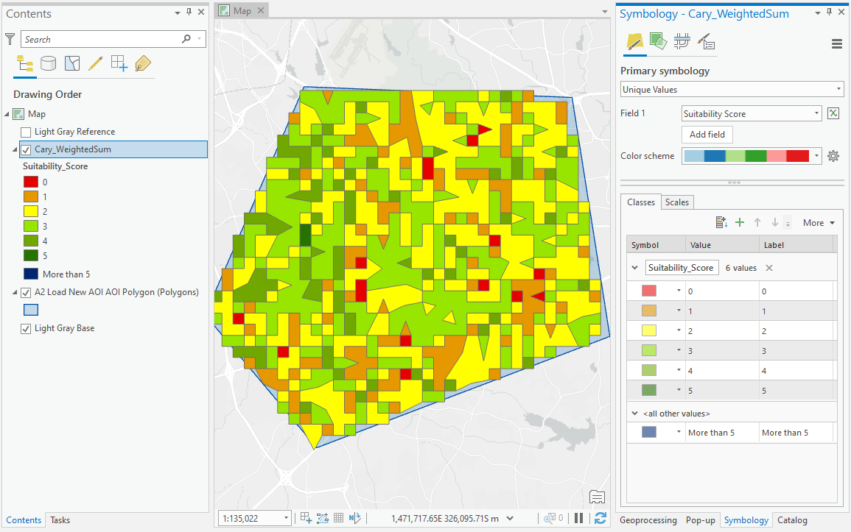

Figure 31. Select Suitability Symbology

This suggested symbology makes it easier to identify which areas are potentially more suitable for waste storage and/or staging. Dark green represents more suitable areas, where red represents less suitable areas.

 Note: Because users can adjust the weights of each data layer to user-defined values, suitability scores can vary from those shown.

## Add Secondary Data to Support Analysis (optional)

There are several additional data types that, while not incorporated directly into the model, can be used in conjunction with the suitability analysis to select waste storage and/or staging sites. Specific *types of locations* (Federal/State facilities, landfills, parks, etc.), natural or manmade environments to *avoid*, and topographic features and transportation-related infrastructure that have *favorable characteristics* for storage and staging sites can be identified using several datasets and map layers. As described in Chapter 2, additional geospatial layers can be used in conjunction with the suitability ratings that are generated by the tool to support site selection.

Add additional data using standard ArcGIS Pro Add Data feature accessible from the layers ribbon area. Data can be used to aid candidate site selection. Leveraging standard functions that control transparency, zoom level and visibility of layers may all be useful to support visualizing suitability ratings in conjunction with other data representing additional suitability considerations. Table 4 below lists potential datasets and map layers to consider including in the analysis.

| Table 4. Candidate Datasets and Map Layers for Base Layers and Storage/Staging Criteria | | |
| --- | --- | --- |
| **Base Layers** | **Suggested Dataset/Resource\*** | **Suggested Website\*\*** |
| ***Temporary Storage and Staging Site Avoidance Criteria*** | | |
| Critical Habitats for Threatened Animal and Plant Species | U.S. Fish and Wildlife Service (USFWS) | <https://ecos.fws.gov/ecp/report/table/critical-habitat.html> |
| Flood Zones | Federal Emergency Management Agency (FEMA) | <https://www.fema.gov/national-flood-hazard-layer-nfhl> |
| EnviroAtlas Estimated Floodplain | <https://enviroatlas.epa.gov/enviroatlas/DataFactSheets/pdf/Supplemental/EstimatedFloodplains.pdf> |
| Historic Sites | National Park Service (NPS) | <https://www.nps.gov/subjects/nationalregister/data-downloads.htm> |
| Public Water Supplies; Well Fields; Potable Water Wells; Sole Source Aquifers | USGS, EPA State Drinking Water Office | <https://water.usgs.gov/maps.html>  <https://catalog.data.gov/dataset/national-sole-source-aquifer-gis-layer> |
| Rare Ecosystems | EPA EnviroAtlas | <https://www.epa.gov/enviroatlas/ecosystem-rarity-toolbox> |
| Sensitive Surrounding Land Uses (schools, nursing homes, hospitals, residential, etc.) | Homeland Infrastructure Foundation-Level Data (HIFLD) | <https://hifld-geoplatform.opendata.arcgis.com/> |
| Wetlands | USFWS, National Wetlands Inventory | <https://www.fws.gov/wetlands/data/data-download.html> |
| Abandoned Quarries | USGS Abandoned Mine Lands Initiative | <https://www.usgs.gov/centers/gggsc/science/usgs-abandoned-mine-lands-initiative?qt-science_center_objects=0#qt-science_center_objects> |
| Archaeological Sites | Reference county-level data, if available  Designated State Historic Resources Trustee | Not applicable |
| Obstructions (power lines and pipelines) | HIFLD Electric Power Transmission Lines and Various Pipeline layers  State or Public Utility Commission | Power Lines <https://hifld-geoplatform.opendata.arcgis.com/datasets/electric-power-transmission-lines>  Pipelines <https://hifld-geoplatform.opendata.arcgis.com/search?q=pipeline> |
| ***Temporary Storage and Staging Site Additional Considerations*** | | |
| Socioeconomic/Environmental Justice | EPA’s Environmental Justice Screen (EJSCREEN) | <https://catalog.data.gov/dataset?q=ejscreen&sort=score+desc%2C+name+asc> |
| Prevailing Winds | National Oceanic and Atmospheric Administration’s (NOAA) National Centers for Environmental Information | <https://www.ncdc.noaa.gov/societal-impacts/wind/> |
| ***Examples of Temporary Storage and Staging Site Locations*** | | |
| City/County-owned Properties | Reference county-level data, if available | Not applicable |
| Commercial/Industrial Facilities (rail yards, industrial parks, licensed rad users, nuclear power plants) | EPA’s National Emissions Inventory (NEI) | <https://www.epa.gov/air-emissions-inventories/national-emissions-inventory-nei> |
| Federal Facilities | DOT’s Military Bases, Bureau of Land Management’s (BLM) Federal Lands, Protected Areas, and Federal Facilities | Military Bases <https://catalog.data.gov/dataset/military-bases-national>  Federal Lands <https://catalog.data.gov/dataset?tags=federal+lands> |
| Landfills | HIFLD Open | <https://hifld-geoplatform.opendata.arcgis.com/datasets/solid-waste-landfill-facilities> |
| Parking Lots | UFWS National Wildlife Refuge System | <https://www.fws.gov/refuges/roads/geospatial.html> |
| Parks | National Park Service  Reference county-level data, if available | <https://irma.nps.gov/DataStore/Reference/Profile/2224545?lnv=True> |
| Rights-of-Way | Data.Gov (various layers) | <https://catalog.data.gov/dataset?tags=right-of-way> |
| Recycling Facilities | Reference county-level data, if available | Not applicable |
| Transfer Stations | Reference county-level data, if available | Not applicable |
| Vacant Lots | Reference county-level data, if available | Not applicable |

* These are quality national datasets; however, local data may have improved resolution for smaller study areas. Note that other data sources may require additional preprocessing for use in this model.

** All websites were last accessed on December 8, 2020.

## Select Your Designated Staging Areas

Following the completion of the suitability analysis, including evaluating additional suitability and avoidance features using other secondary data, prepare to make your staging site selection by making the **WeightedSum** feature class your only selectable layer. Do this by right clicking on the **WeightedSum** feature class in the contents and selecting **Selection** > **Make This The Only Selectable Layer** as shown in Figure 32.

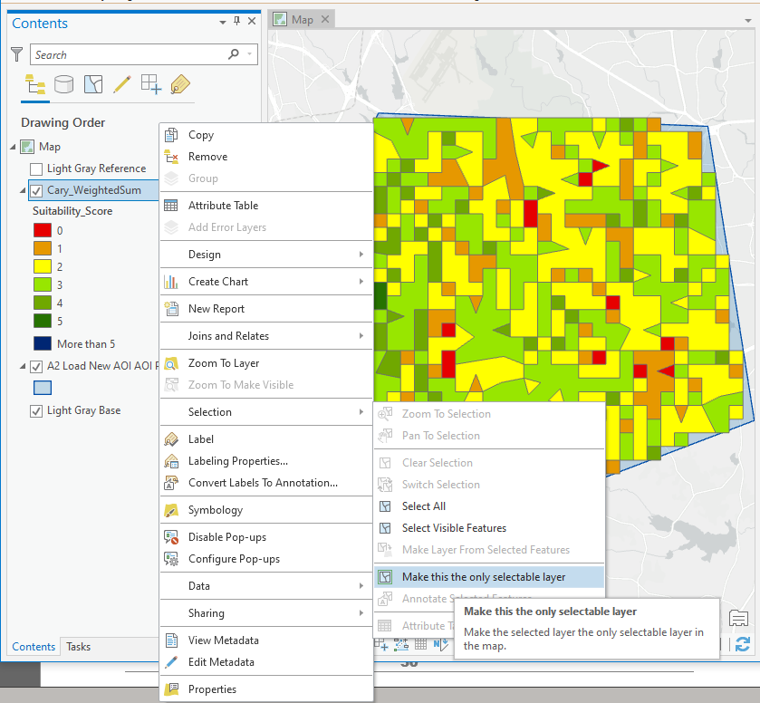

Figure 32. Set Selection Environment

 Note: The summary is only based on selections made against the WeightedSum layer. Performing the step above is optional and recommended for novice users.

Click **Map** > **Select** in the **Menu** toolbar to interactively select multiple features as potential staging sites as shown in Figure 33 below.

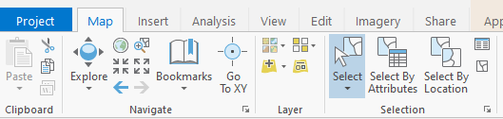

Figure 33. Interactive Selection Method

Make your selections by clicking each polygon. As shown in Figure 34, those features will then be highlighted to confirm features are selected. Note that there are no limitations on the number of areas you may select to include in your results. Hold the Shift key to click multiple areas.

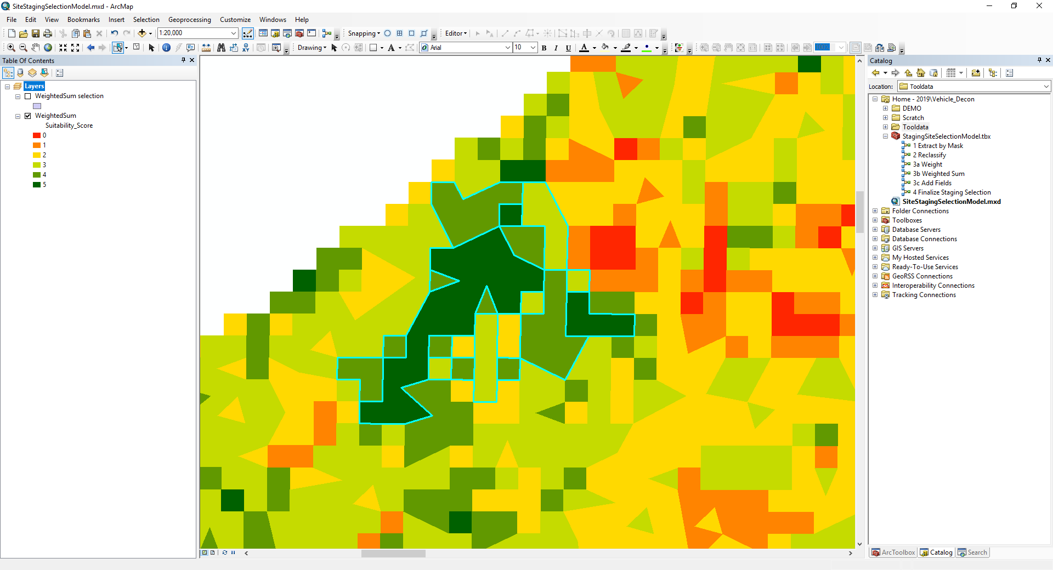

 There are multiple ways to select features and users with more advanced GIS skills can leverage more automated and advanced selection techniques. Several common approaches include:

1) Freehand (point and click, drag, lasso)

2) Select by Attributes using SQL (e.g., suitability score > 4)

3) Select by Location/Intersect

Figure 34. Selected Features

## Modify Storage/Staging Area Attributes (optional)

The tool includes several optional fields to include with results output, including:

* Name,
* Contamination Type, and
* Notes.

These are flexible fields that users can tailor to their specific use. For example, Name could be used to designate more than a descriptor, such as priority level, use order, etc. Contamination Type can be used to explicitly designate parcels for staging/storing waste from a specific event type (e.g., chem, bio, rad). Completing these fields is optional; however, doing so will also invoke an aggregation function in the output where not only will individually entered records and attributes be retained, but the tool will also group and sum any parcels that are associated with the same Name and/or Contamination Type identifier.

To modify selection attributes, right-click the **WeightedSum selection** and select **Attributes**. This will open the **Attributes** pane where you can select one of the features, as shown in Figure 35. Next update the **Name, Contamination Type** and/or **Notes** fields and click **Apply** to save the changes.

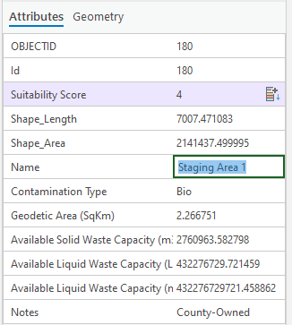

Figure 35. Edit Attributes

## Step 3. Finalize Staging Parcel Selection

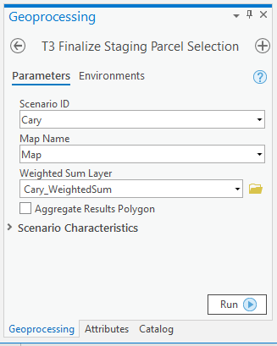

Figure . Step 3 Finalize Staging Selection

Run the **Finalize Staging Parcel Selection** tool by clicking **Run** in the Taskspane or by double-clicking on the **T3 Finalize Staging Parcel Selection** model in the **EPA-Storage-Staging-Site-Tool.pyt** from the Catalog window. This will open the **T3 Finalize Staging Parcel Selection** model in the Geoprocessing pane as shown in Figure 36. The **T3 Finalize Staging Parcel Selection** model aggregates the features in each staging site, averages the suitability score from the features within the aggregated feature, and calculates the area, solid and liquid storage capacity volumes, and centroids of the aggregated features. Click **Run** to run the **T3 Finalize Staging Parcel Selection** model. At this point the staging site selection is complete. Click **Next Step**  in the Tasks pane to continue to the next step.

 Note: Checking/unchecking the Aggregate Results Polygon will control whether the tool retains individual polygons in the output layer or creates a dissolved, single polygon for all individual parcels selected.

The new layer will automatically have **StagingSiteSelection** appended to the name and exported to the **EPA-Storage-Staging-Site-Tool.gdb**. The example output pictured in Figure 37 below includes the following attributes:

1. Id
2. Suitability Score
3. Shape Length (meters)
4. Shape Area (meters)
5. Name
6. Contamination Type (Any, Chem, Bio, Rad)
7. Geodetic Area (in square kilometers)
8. Centroid Coordinates
9. Available Solid Waste Capacity (cubic meters)
10. Available Liquid Waste Capacity (liters)
11. Available Liquid Waste Capacity (cubic meters)
12. Notes

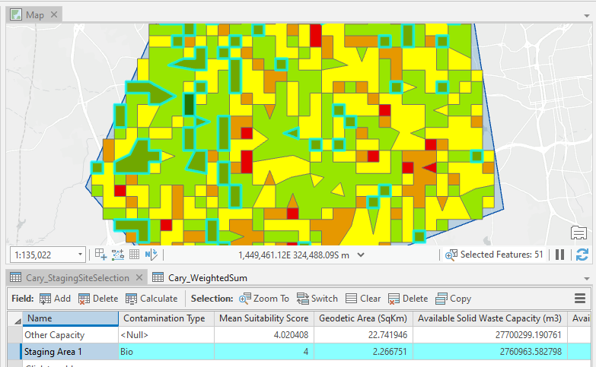

Figure 37. Final Staging Selection Output

Staging and storage capacities are estimated for both solid and liquid waste considering the overall site area, an approximated buffer zone required for site operations, and limitations related to stacking waste. The tool assumes that 60 percent of the candidate site area will be used for roads, buffers, burn pits, household hazardous waste (HHW) disposal areas, etc.[15] The following equations are used to estimate the amount of solid and liquid waste volume a candidate site can accommodate:

* Available Solid Waste Capacity (m3) = [ Available Site Area (m2) * 0.4 ] / Solid Waste Area Factor 0.3284 (m2/m3),
* Available Liquid Waste Capacity (L) = [ Available Site Area (m2) * 0.4 ] / Liquid Waste Area Factor 0.0020975 (m2/L), and
* Available Liquid Waste Capacity (m3) = Available Solid Waste Capacity (L) * (1 m3/1000 L) – This second computation is provided to facilitate easier comparison with other HSRP tool outputs.

## Step 4. Export/Save Results

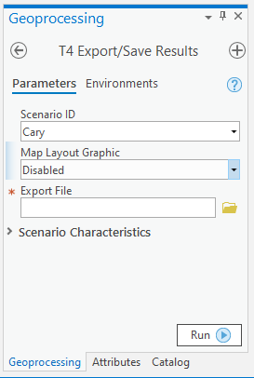

Figure . Step 4 Export Report Screen – Disabled Map Graphic

Run the **Export/Save Results** tool by clicking **Run** in the Tasks pane or by double-clicking on the **T4 Export/Save Results** tool in the **EPA-Storage-Staging-Site-Tool.pyt** from the Catalog window. The **T4 Export/Save Results** tool exports the results as an Excel spreadsheet. As shown in Figure 38, if more than one scenario was created, users can select the **Scenario ID** dropdown for the results set of interest to export. Users can then specify a file name and the location to save results by clicking the Folder Icon | | Vector Images Icon Sign And Symbols icon, selecting where to save the results file.

A few additional options exist depending on whether users want to include an image with their export (requires Pillow extension) and familarity with ArcGIS Pro Map Layout options. As shown in Figure 38, including the map layout graphic is disabled by default.

Alternatively for more advanced ArcGIS Pro users, the tool offers features to work with Map Layout options. As shown in Figure 39, selecting **Layout** will present additional options for specifying the map layout frame and auto zooming specifications. Users can adjust any of these selections, including setting the **Map Layout Frame For Zoom** to Disabled.

After selecting either option for including a map in your export, click **Run** to export results to an XLS workbook. Click **Finish** in the Tasks pane to complete the **Run Suitability Analysis** feature.

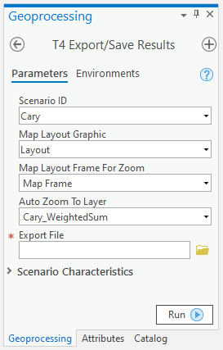

Figure . Step 4 Export Report Screen – Map Graphic Enabled

### Results Output

The tool exports results and saves output into a Microsoft Excel workbook. The workbook includes two tabs:

* **Summary** – Provides an aggregated view of the capacity of selected sites, the scenario characteristics that are associated with the results, and includes a snapshot of the image if the option was enabled by the user.
* **Selected** – Provides individual records for each selected parcel in tabular format.

Results for individual scenarios will be exported separately. Users can pull worksheets into a single workbook to facilitate comparisons and track how differences in scenario conditions impact results.

### Create and Compare More than One Scenario

After completing Step 3 for a specific scenario, users can create additional scenarios to support comparative analyses. For example, a user may want to assess whether relaxing any suitability exclusion criteria or changing the weight of essential data makes a significant impact on capacity. Users can return to any steps previously completed and make adjustments. To preserve the adjustments for comparison purposes, the user should assign unique Scenario ID. Step 4 allows users to specify which ID should be referenced when exporting results. Users can make selections using the drop-down menus that are available in the pane.

# Troubleshooting



7

CHAPTER

Read about issues and resolutions to common problems

This chapter provides solutions to commonly found problems that users may encounter using the tool. It is recommended that you confirm software and hardware compatibility (information found in Chapter 3 of this document) before continuing.

| **Problem** | **Cause** | **Remedy** |
| --- | --- | --- |
| Python extensions not working as expected. | Pro Conda Python manager | Recreate my alternative Python environment |
| Received error message when trying to execute tool:  “Tool Not Licensed.  Unable to execute the selected tool. You do not have the necessary license to execute the selected tool.  ERROR 010096: There is no Spatial Analyst license currently available or enabled.” | The spatial analyst extension has not been enabled. | Select Customize (from the menu at the top of the map document).  In the Customize menu, select Extensions.  Check the box beside the Spatial Analyst Extension.  <https://support.esri.com/en/technical-article/000020013> |
| Failed to Load New AOI | AOI ID contains spaces, hyphens, underscores, or starts with an integer | Rename AOI using on letters with no spaces and do not begin with an integer. Click Run again. |
| Failed to Load New Scenario | AOI input files not properly mapped to essential data categories (i.e., wrong source file selected). | Re-run the A2 Load New AOI and verify correct source files are selected for each essential criteria category. |
| Scenario Storage has not been initialized | Attempted to run suitability analysis without first initializing the scenario. | Run the B1 Scenario Setup step and try again. |
| No scenarios found in system | Attempted to run suitability analysis without first creating a scenario. | Run the B2 Load New Scenario step and try again. |
| Image results fail to export | You chose to include a clip of the map with your export, but you do not have PIL installed in your Python environment to fetch image objects. | Install PIL (see Chapter 3) or select “Disable” and export results without the map image. |
| Results cannot be exported to the specified file. | Excel has locked the file that is open with the same name. | Close the open file or use a different filename to export results. |
| General unexplained error | Project installation corrupt. | Reinstall project from scratch. |

This concludes the User’s Guide. If you have any questions, please email the point of contact listed in Chapter 1.

U.S. Environmental Protection Agency

Homeland Security Research Program

Research Triangle Park, NC 27711

1. U.S. Department of Homeland Security, “Key Planning Factors for Recovery from a Radiological Terrorism Incident,” LLNL-TR-574123/E1036, Washington, DC, September 2012, <https://www.fema.gov/media-library-data/20130726-1911-25045-2546/30_rrkp_key_planning_factors_radiological_incident.pdf>. Last accessed December 7, 2020.
2. U.S. Department of Homeland Security, “Key Planning Factors for Recovery from a Biological Terrorism Incident,” Washington, DC, Summer 2012, <https://www.fema.gov/media-library-data/20130726-1910-25045-1918/20_rrkp_key_planning_factors_biological_incident.pdf>. Last accessed December 7, 2020.
3. U.S. Department of Homeland Security, “Key Planning Factors for Recovery from a Chemical Warfare Agent Incident,” Washington, DC, Summer 2012, <https://www.fema.gov/media-library-data/20130726-1910-25045-7886/10_rrkp_key_planning_factors_chemical_incident.pdf>. Last accessed December 7, 2020.
4. FEMA, “Debris Management Guide,” FEMA-325, Washington, DC, July 2007, <https://www.fema.gov/pdf/government/grant/pa/demagde.pdf>. Last accessed December 7, 2020.
5. FEMA, “Debris Management Plan Workshop Student Handbook,” Supplement to FEMA P604, Washington, DC, September 2009, <https://www.fema.gov/pdf/government/grant/pa/dmpw_handbook.pdf>. Last accessed December 7, 2020.
6. United Nations Office for the Coordination of Humanitarian Affairs, “Disaster Waste Management Guidelines,” January 2011, <https://www.unocha.org/sites/unocha/files/DWMG.pdf>. Last accessed December 7, 2020.
7. Cheng and Russell G. Thompson, “Application of boolean logic and GIS for determining suitable locations for Temporary Disaster Waste Management Sites,” International Journal of Disaster Risk Reduction, Volume 20, 2016,

   Pages 78-92, ISSN 2212-4209, <https://doi.org/10.1016/j.ijdrr.2016.10.011>. <http://www.sciencedirect.com/science/article/pii/S2212420916301881>. Last accessed December 7, 2020.
8. Lemieux, Paul, “Practical Considerations and Operational Recommendations for Waste Staging for Wide-Area Radiological Releases,” EPA/600/R-15/317, Washington, DC, July 2016. 10.13140/RG.2.2.19600.81920.
9. Lemieux, Paul, “Best Practices for Management of Biocontaminated Waste,” EPA/600/R-16/251, Washington, DC, October 2016. 10.13140/RG.2.2.22956.26248.
10. Extensions are specifically needed for the reclassification and weighting steps that are required to generate suitability ratings.
11. Documentation for Pillow is available at: <https://pypi.org/project/Pillow/> (Last accessed: December 7, 2020)
12. Essential data were downloaded in March 2020 from the source locations described in Table 1.
13. [Urban Hydrology for Small Watersheds](https://www.nrcs.usda.gov/Internet/FSE_DOCUMENTS/stelprdb1044171.pdf) (Natural Resources Conservation Service, United States Department of Agriculture, Technical Release–55), Appendix A, updated January 1999.
14. Soil hydrologic groups reflect infiltration rates based on soil profiles and are used as a surrogate to identify areas that would more likely limit the infiltration and movement of contaminants.
15. Lemieux, Paul, “Practical Considerations and Operational Recommendations for Waste Staging for Wide-Area Radiological Releases,” EPA/600/R-15/317, Washington, DC, July 2016. 10.13140/RG.2.2.19600.81920.